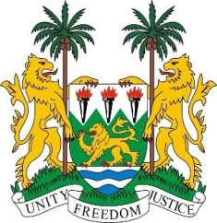
SIERRA LEONE
24th Session of the UPR

UPR of SOMALIA

22 January 2016

Mr President,

Sierra Leone welcomes the delegation of Somalia and thanks them for their national report.

Since the last review, the Federal Government of Somalia has faced complex challenges in maintaining the rule of law, addressing the grave security threats and in protecting the human rights of all those living within its borders.

In this regard, we commend the government for working with the African Union through AMISOM to combat the terrorist group, Al-Shabab.

Equally noteworthy is the adoption of the Somali Provisional Constitution in 2012 and the Action Plan for Human Rights Roadmap for Somalia. Sierra Leone calls on the international community to provide all required technical assistance for implementation of the Roadmap.

Sierra Leone commends Somalia for the ratification of the CRC in 2015, and would encourage Somalia to provide legal clarification on the age of the child in their national legislation.

Recommendations:

- Ratify CEDAW, ICPPED and ICRMW.
- Thoroughly investigate and prosecute all reported cases of sexual violence, and ensure that support and compensation is provided to the victims.
- Adopt comprehensive policies abolishing child, early and forced marriage.
- Submit overdue reports to the relevant UN treaty bodies.

Sierra Leone wishes Somalia a successful review.

Thank you, Mr President.

